CS370 PHASE 3 PROJECT USER MANUEL

ALIZA ABBAS

12/04/17

How to run the code:

Using command line, go in the directory, run java program with 3 arguments, input, log and output Files. Here is an example:

* javac CS370Phase3.java
* java CS370Phase3 /Users/alizaabbas/Documents/netbeans-proj/CS370Phase3/src/cs370phase3/input.txt /Users/alizaabbas/Documents/netbeans-proj/CS370Phase3/src/cs370phase3/log.txt /Users/alizaabbas/Documents/netbeans-proj/CS370Phase3/src/cs370phase3/inv.txt

The picture below shows the main GUI for my inventory, which performs the functions of viewing, deleting, adding and modifying the items. Also, now you can do an advance Search on the items, which would be filtering the items within your price range.

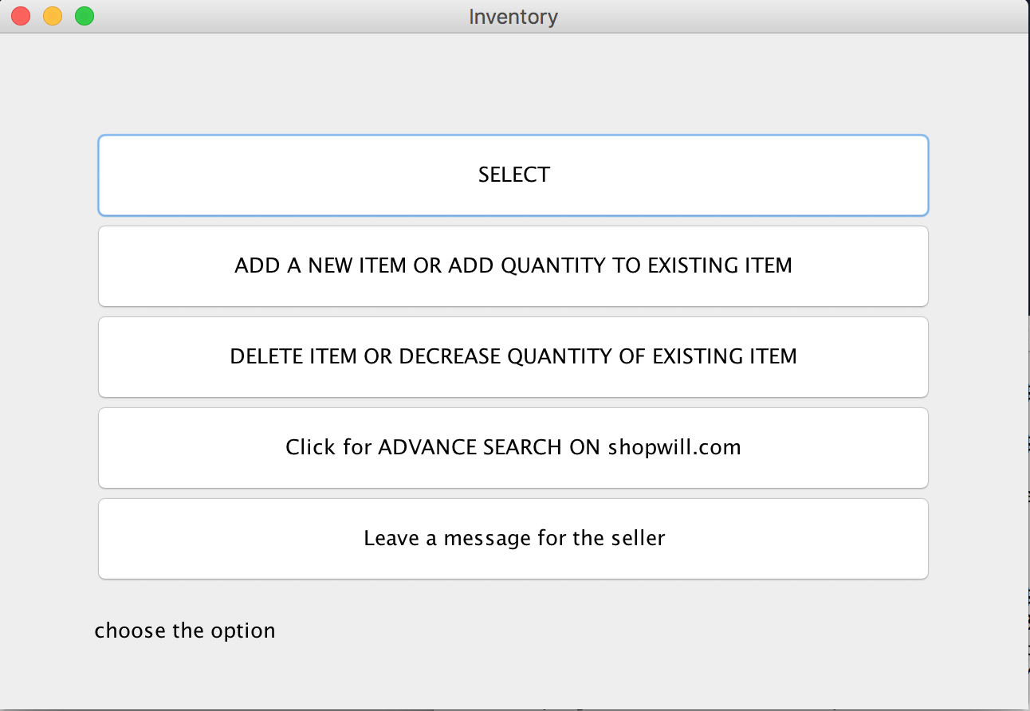

When you click the select Button, its going to ask you for the inventory number of the items that you want to get displayed.

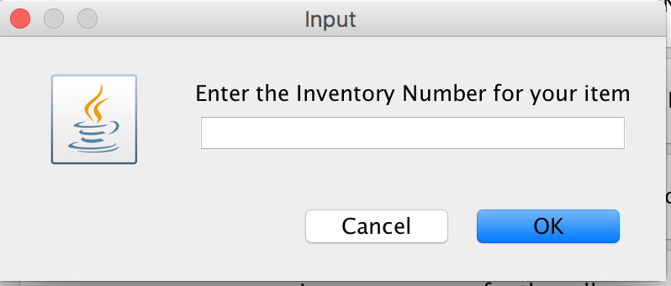

After entering the inventory number and clicking OK, it will show you the information stores for the selected item.

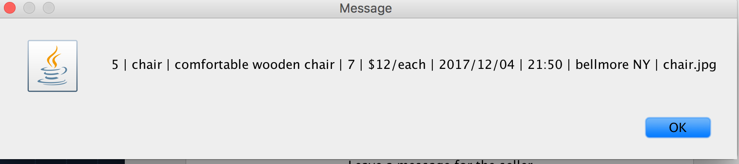

ADD OR DELETE BUTTONS: When you click these buttons, window will popup asking for the inputs for the item, either to be inserted, modified or deleted, and the action will be performed.

The advance Search Option: advance search will ask you for the title of the item you’re searching, minimum price and maximum price and then will show you the list of items within that range, like below:

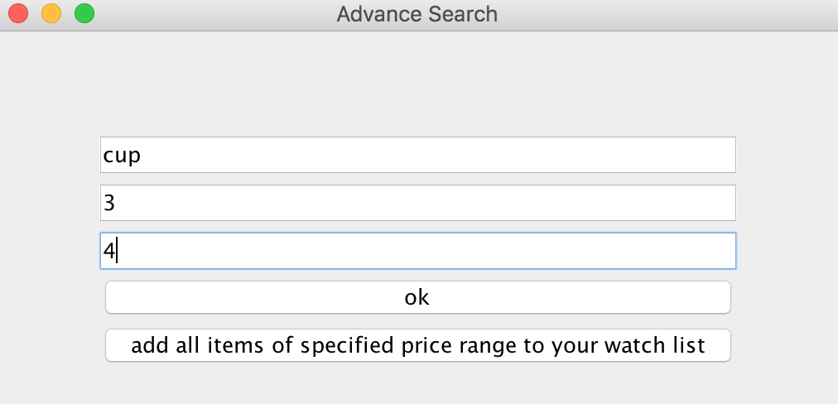

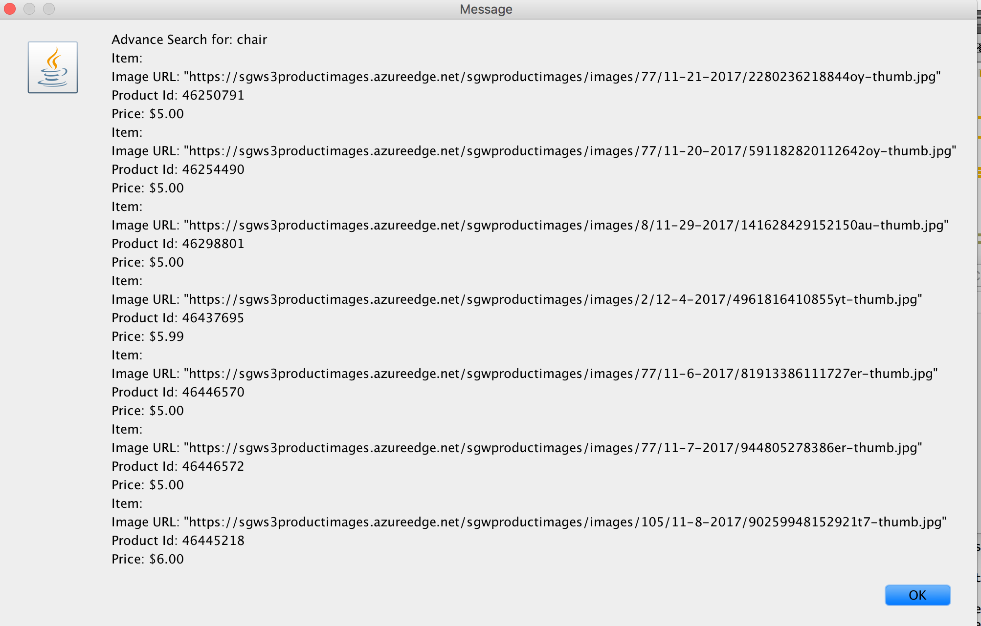

Two innovations:

1. On the main inventory page, you have a button for leaving a message to the seller, this button could be used for special queries that you need from the seller, making you directly interact with them.
2. On the advanced Search window, there is an option to add all the filtered items for your range to your watch list.

Sample Input File:

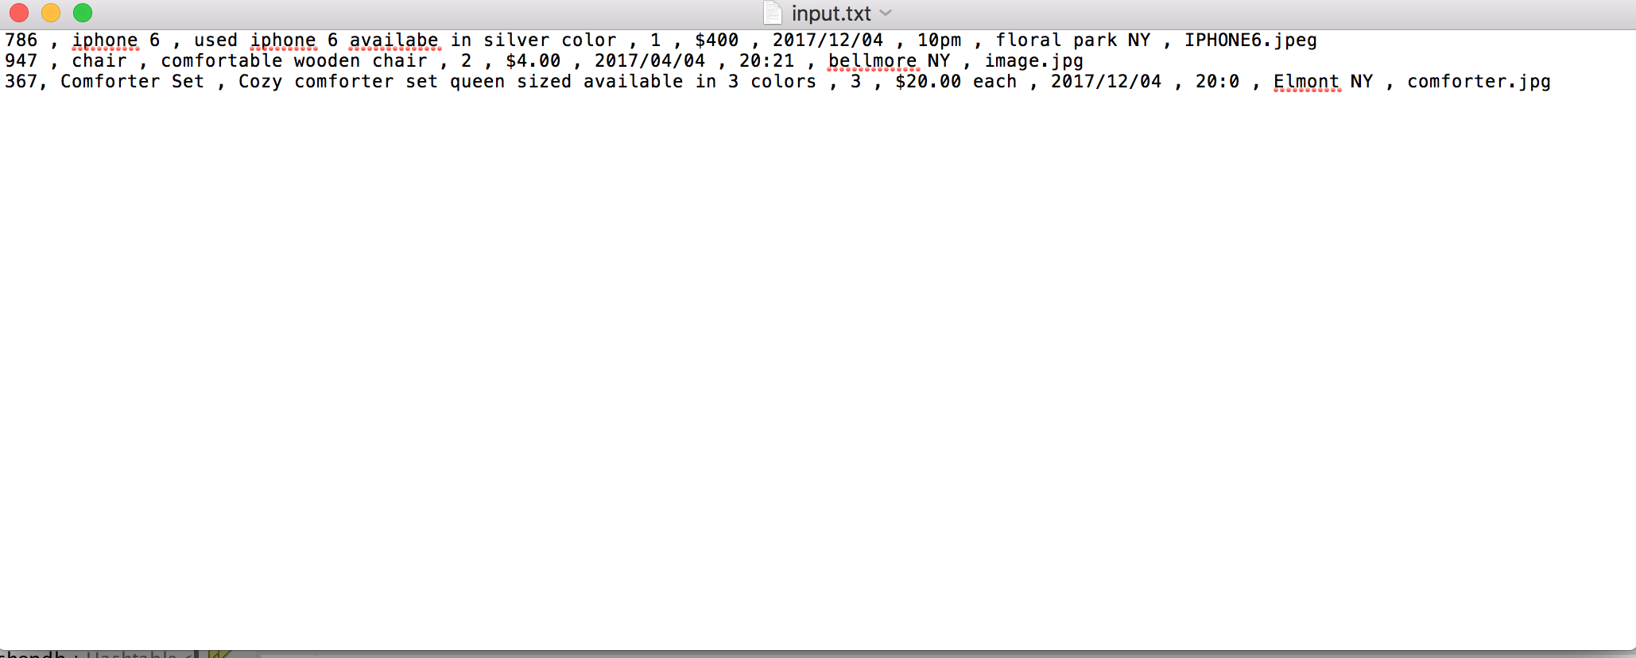

Sample Output File:

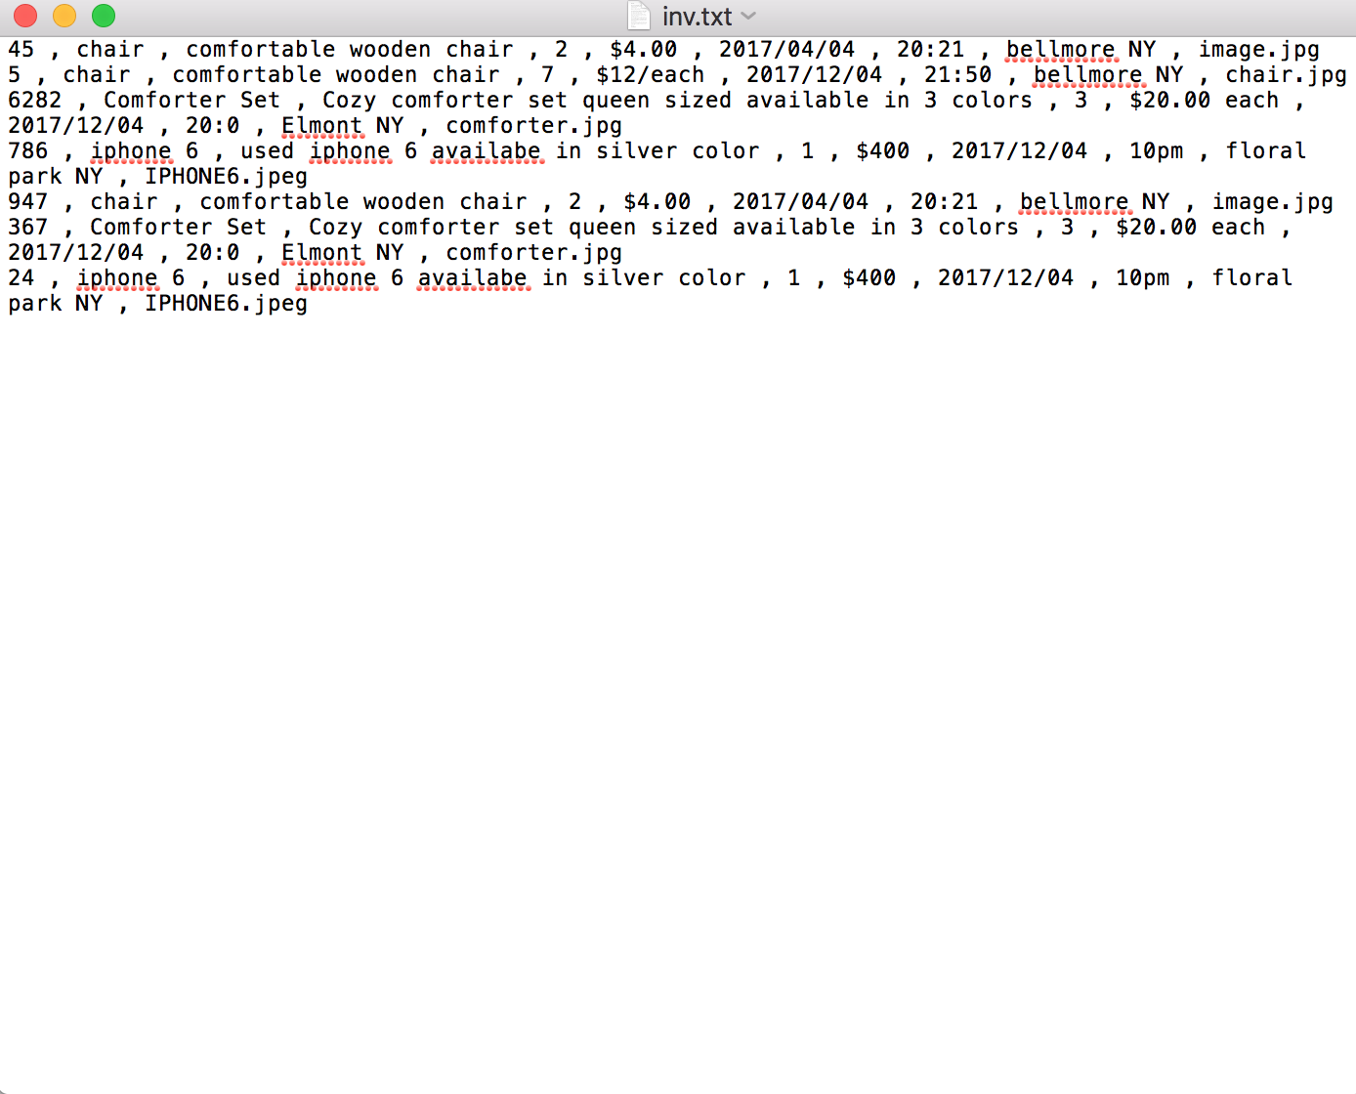

Sample Log File:

